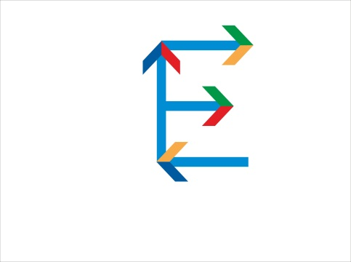
1st Summit “Nova Europa: Europe of Ideas” of Young Political Leaders from “New” EU Member States
Zagreb, 23-24 October, 2015
ZAGREB RESOLUTION

We, the representatives of parliamentary represented political parties from Croatia, Slovenia, Hungary, Slovakia, Latvia, Lithuania and Bulgaria
Recognizing the differences in our political ideologies and party platforms,
Recalling the relatively different historical, political, economic and social paths our states have followed,
Noting that the present-day interests of our states do not always coincide,
Acknowledging that the prolonged financial crisis and the persistent inflows of refugees and migrants from conflict-torn regions have placed enormous strain on our countries’ economies and/or on inter-country relations,
Deploring the insufficient unity of European Union Member States and the slow decision-making processes of the Union which threaten the future of the European project and its citizens, yet
Attempting to overcome our personal and political biases through respect for and dialogue with our political opponents,
Identifying that our states share common domestic and international challenges in the areas of youth unemployment, energy diversification and security, transport connectivity, refugee and migratory crisis, and foreign policy,
Believing in the importance of cooperation as the foundation for further growth, development and democratization,
Recognizing that political stability is the foundation for economic development and growth,

PROMOTE the initiation of a broader, deeper and nationally balanced debate on the future of the European Union and its institutions,
URGE for the equal treatment of all EU Member States and their residents, while respecting our cultural diversity,
SUPPORT the cooperation in the Baltic-Adriatic-Black Sea region, in particular in the areas of economy, security, transport, energy, and research and innovation.
CALL for the further and sustainable economic development of “new” EU Member States, through the improvement of the single market, and promotion of entrepreneurship, knowledge-intensive manufacturing, the exploration of new markets, and economies of scale,
BACK the improvement of the transport connectivity between the states of the Baltic-Adriatic-Black Sea region as a foundation for the intensification of business, cultural and political exchange,
STRESS the importance of young generations for both economic development and social concord and CALL for increased opportunities for their early involvement in positions of responsibility in the political and economic sectors,
EMPHASIZE the importance of energy diversification and collaboration between “new” Member States for the reduction of their energy dependency which places significant strain on national economies, and CALL for an active approach on local, regional and EU level towards the diversification of energy sources and supply,
REQUEST a common European Union approach, taking into consideration the point of view of “transit” countries, towards the lasting tackling of the refugee and migratory crisis which shows no indication of slowing down.
CALL all key national and European Union actors to respect the fundamental European values and provide real solutions instead of looking for short-term political gain.
CALL for new content and ideas to address the contemporary challenges our countries and the broader European Union face.

