A Hidden Portrait of Jane Austen?

[The following was the postscript to an article by me called ‘Partiality and Prejudice: The young Jane Austen’s surprising marginalia’, published in the Times Literary Supplement of 1 February 2008. The piece was all about Austen’s youthful ardour for the Stuart cause and its origins in her mother’s family history: the Leighs of Stoneleigh and Adlestrop had been ‘noted for inflexible loyalty to the House of Stuart through every change of fortune that befell its monarchs’ and in the ‘History of England’ that Jane Austen wrote as a teenager, she famously berated the Tudors and praised all the Stuarts, especially ‘that bewitching Princess’ Mary, Queen of Scots, whom she calls ‘one of the first Characters in the World’. The full article can be read via the Austen and Archive pages at www.claireharman.com]

In the summer of 1806, when Jane Austen was thirty years old, she, her sister and widowed mother paid a visit to their relation the Rev Thomas Leigh in Adlestrop just a few weeks after he had inherited a life interest in Stoneleigh Abbey on the death of a childless cousin. The terms of the will were complicated, the estate large and valuable, and Leigh was advised by his lawyer to cement his claim by taking immediate possession. The house party at Adlestrop therefore removed north to Stoneleigh, much to the pleasure and interest of the Austen women, none of whom had seen the old family seat during the lifetime of the eccentric and reclusive previous owner. The visit prompted a memorable letter from Mrs Austen to her daughter-in-law Mary describing the splendours of the house, and is thought to have fed into many of Jane Austen’s feeling portraits of lavish homes, notably Northanger Abbey. Mother and daughters were amazed by Stoneleigh; the Avon flowing through the grounds, the forty-five windows of the front elevation, the State Bedroom (‘an alarming apartment just fit for a Heroine’, as Mrs Austen described it), eighteen menservants expensively attired in mourning. Mrs Austen’s pleasure in this brief exposure to Leigh luxury (her own birthright, after all) is obvious as she reports ‘eating Fish, venison & all manner of good things, at a late hour, in a Noble large Parlour hung round with family Pictures – every thing is very Grand & very fine & very Large’.
There was, however, a Stuart treasure in the old gallery of the house which, had they known of its existence, would have pleased Mrs Austen – and Jane – even more, but which wasn’t discovered for another twenty years. For, as Mary Augusta Austen-Leigh related in Personal Aspects of Jane Austen, the art connoisseur Sir George Beaumont noticed an eye staring out from a still life when he was visiting Stoneleigh in 1827. On investigation, there was found to be a completely different picture underneath; an oil portrait of Charles I by Vandyke. Mary Augusta speculated that the portrait was probably a gift from the King to ‘loyal Leigh’ after his reception at Stoneleigh during the Civil War, which had been overpainted with the innocuous flower piece ‘to save [it] from the thrust of some Parliamentary pikestaff’. The measure seemed to have been so effective that ‘not even a tradition of the portrait had survived’, though, as Mary Augusta notes, it would have particularly delighted Jane, for whom ‘every story or relic connected with these historic memories of the Stuarts must have been deeply interesting’.
As a coda to these remarks on Austen’s ardour for the Stuarts, I would like to consider another portrait that has been in plain sight since the author’s youth, but also perhaps includes an element of concealment. It was executed in that very parlour where Virginia Woolf imagined Austen sitting laughing to herself in a corner and it was commissioned (as it were) by Austen herself. It is Cassandra Austen’s picture of Mary Queen of Scots in Jane’s ‘History of England’, one of thirteen charming watercolour vignettes by the author’s elder sister, then 18 years old, painted directly onto the manuscript in circular frames drawn around something about the size of a custard glass.
Cassandra’s illustrations mimic the medallion portraits in Goldsmith’s History of England insofar as they portray each monarch in a circular frame at the beginning of the relevant chapter, with the name of the subject on the top and that of the artist below. But the style of Cassandra’s portraits is very different from the formal and highly stylised illustrations to Goldsmith. Jan Fergus (in her introduction to a 1995 edition of Austen’s ‘History of England’) opened up the question of possible contemporary identifications in the illustrations and reported the discovery of one Mary Millard that two of Cassandra’s images, the portraits of Edward IV and Henry V, were close copies of figures in H.W. Bunbury’s 1780 satirical print, ‘Recruits’. This remarkable piece of detection raises the possibility of course of all the Cassandra pictures being copies from elsewhere: indeed the cynic, looking at Cassandra’s few surviving artworks (including the anatomically unsatisfactory study of Jane’s back view and the famous pencil sketch, now in the National Portrait Gallery, of Jane with her arms folded), might say she was unlikely to have produced the charming ‘History of England’ illustrations entirely unaided.
The illustrations are notable for their anachronistic dress and comic lack of resemblance to any well-known images of the monarchs in question. Henry IV, for example, is a slight figure in a very 1780s pale blue jacket and powdered wig, Henry VII is a scruffy, bearded beggar, Henry VIII a burly bruiser with a red bobble-cap and five o’clock shadow. Charles I is depicted as a very young, fair man in a modern jacket and hat, possibly copied from a contemporary print, or – why not? – from a contemporary young man. For if Charles Austen hadn’t been only twelve years old at the time these illustrations were made, I would be tempted to suspect an elaborate sibling joke going on. Apart from one, Francis (who is given a separate tribute in the text as the likely successor to the naval glory of Sir Francis Drake), Jane and Cassandra’s brothers all had the names of English kings - James, Edward, Henry, Charles - and the pictures in Jane’s ‘History of England’ of James I, Edward VI, Henry V and Charles I are all of good-looking, late eighteenth-century youths.
Which brings us to Cassandra’s picture of the ‘bewitching Princess’, Mary Queen of Scots; a pink-cheeked, round-faced, cherry-lipped heroine in a white dress and veil, with blue trimmings to match her eyes. It is notable for being the only one of the illustrations that attempts to show the subject in dress of appropriate date. If Cassandra had been looking for an image to copy, the most often reproduced portrait of Mary Queen of Scots was by Francois Clouet, painted in 1559 or 60 when Mary was in ‘White Mourning’ (‘deuil blanc’) for the deaths of her husband, mother and father-in-law.
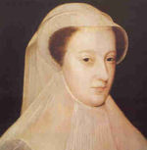
Clouet’s Mary wears a white veil and a fine, white pleated cloth from chinline to chest, possibly the source of the strange pleated chest frill in Cassandra’s picture, which doesn’t otherwise bear any resemblance to a known item of costume. If Cassandra’s picture is based on Clouet’s iconic Mary (endlessly copied, not least by Clouet himself), there are still significant deviations, notably the colour of the hair (Mary’s was always described and depicted as red-brown) and the juvenile fullness and sweetness of the face. Other notable things about this one illustration are it is not of an English monarch (so is, strictly speaking, superfluous: there is no section of Austen’s text titled ‘Mary Queen of Scots’) and it is fitted in next to the picture of Elizabeth, which, appropriately to the text, is as unflattering as Cassandra can contrive.
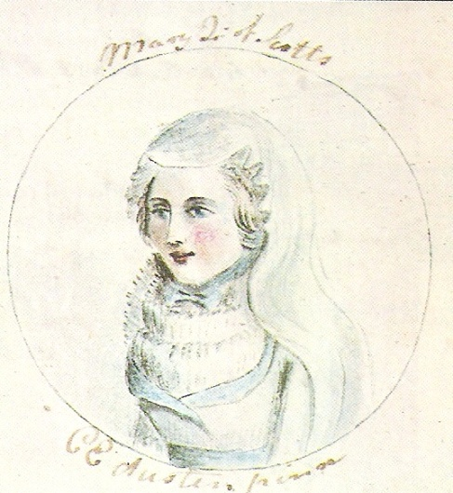
The young Jane Austen had a round face and pink cheeks, a small mouth and a lively expression. She is said to have had light brown hair and hazel-coloured eyes (Cassandra’s picture has blue), but that detail apart, might we not, in the light of Austen’s Stuart-mania, consider the little watercolour of Mary Queen of Scots in ‘The History of England’ as a possible portrait of the young author? Given the opportunity to insert such a joke, could either of the sisters have resisted?
© Claire Harman 2008

Austen Papers, 1704-1856, ed. R.A.Austen-Leigh (London, 1942) pp.244-47
Ibid.
Mary Augusta Austen-Leigh, Personal Aspects of Jane Austen (London, 1920) pp.15-16
Jan Fergus et al (eds) The History of England (Edmonton, 1995) pp.ii-iv. Peter Sabor also has a useful note on this identification on p.457 of Juvenilia.

