To walk invisible
CLAIRE HARMAN
As the bicentenary of Charlotte Brontë’s birth approaches (April 21, 2016), many picture editors, exhibition organizers and publishers will be looking round for a suitable image of the author and perhaps feeling a little disappointed with the available choices. Only two pictures of Brontë survive that were made from life: the first, crudely painted by her brother Branwell when she was a teenager (in the group portrait known as “The Brontë Sisters”), makes the subject look doughy and dull; the second, a chalk drawing commissioned by the publisher George Smith in 1850 and executed by the fashionable artist George Richmond, veers the other way towards flattery. When Richmond’s portrait was published as the frontispiece to Elizabeth Gaskell’s Life of Charlotte Brontë in 1857, two years after Brontë’s death at the age of thirty-eight, it drew some blunt comments from the subject’s old friend Mary Taylor. “I do not altogether like the idea of publishing a flattered likeness”, she told the biographer; “I had rather the mouth and eyes had been nearer together, and shown the veritable square face and large disproportionate nose.”
Taylor was by no means the only person to remark on Brontë’s un-beautiful appearance. Gaskell herself had written of her subject’s “plain, large and ill-set features”, “crooked mouth and large nose”, and in private had been even more specific about “a reddish face; large mouth & many teeth gone; altogether plain; the forehead square, broad and rather overhanging”. George Smith was so impressed by the prominence of Miss Brontë’s brow that he took her to a phrenologist in 1851 to have it analysed, but thought little of her personal charms, recalling that her
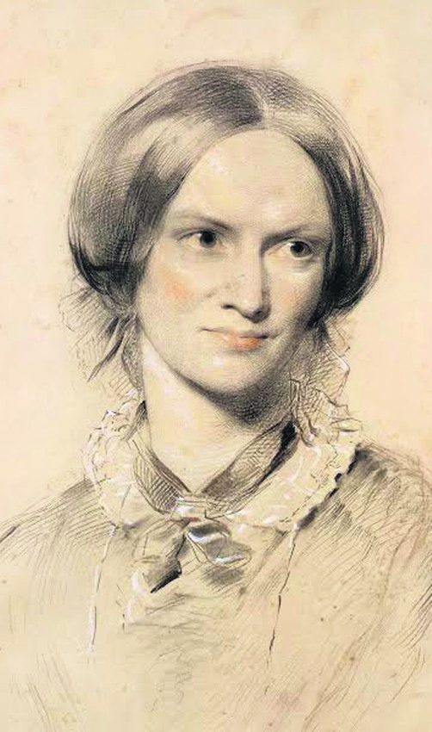

head “seemed too large for her body” and that “her face was marred by the shape of the mouth and by the complexion”. William Thackeray described Brontë as “homely- faced”, “without a pennyworth of good looks”, while his daughter Anne recalled their famous visitor’s defensive and unpleasant demeanour: “I remember how she frowned at me whenever I looked at her, but perhaps it was specially at me – at least so I imagined. There was a general impression of chin about her face”.
These plain-speaking judges did all grant Brontë one outstanding feature; large, shining eyes “of extraordinary brilliance and penetration”. From their descriptions, it seems safe to conclude that Charlotte Brontë had an unusually large brow, large expressive eyes, a wide mouth collapsing over missing teeth and a big nose (like her father, whom she was said to resemble). Richmond’s portrait, for all its prettification, does actually indicate those characteristics in a veiled form.
All the stranger, then, that a photograph that came to light in the 1980s has ever been accepted as showing Charlotte Brontë. The initial excitement was understandable when, in 1984, a glass negative was found in the archives of the photographer Sir Emery Walker at the National Portrait Gallery, with an index card reading “from a carte-de-visite of Charlotte Brontë, taken within a year of her death”. It showed a slightly plump woman in her mid to late thirties, demurely dressed, with even features and a complacent expression. The following year, the very carte-de-visite that Walker had copied was found among papers which had been donated to the Brontë Parsonage Museum in 1974 by George Smith’s granddaughter, Elizabeth Seton-Gordon. It had been kept together with an envelope marked in pencil “Charlotte Brontë ?the only photograph” and a letter from Emery Walker to a member of the publishing firm Smith, Elder and Co, dated January 2, 1918, returning the carte after his negative had been made and saying that he would make another photographic print in due course.
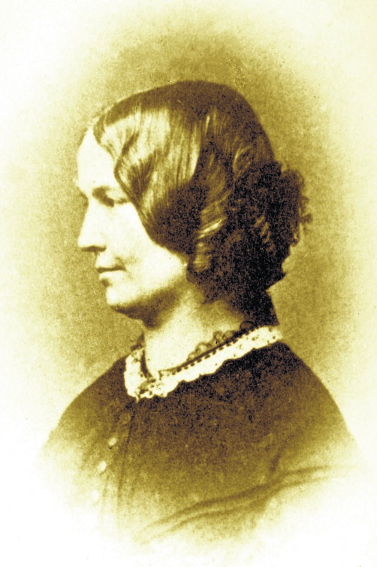
No one at Smith, Elder in 1918 remembered Charlotte Brontë personally, of course. George Smith had died in 1901, and the firm had been run (not very successfully) from 1899 until 1917 by his son-in-law, Reginald Smith. In 1917, it was bought up by John Murray, and the change of management may itself have stimulated interest in the firm’s archives, which included important letters from Brontë to George Smith and his mother, Elizabeth. Only a small nudge was needed to make someone at the firm imagine that a photograph in an archive of Brontë-related material was of Brontë herself, and that nudge was provided by the inscription in ink on the back of the picture, which reads “Within a year of CB’s death”. Emery Walker’s index card took up the cue (“from a carte-de-visite of Charlotte Brontë, taken within a year of her death”), though one can surmise that substantial doubts remained in the publisher’s mind after the negative was made, as the image was not subsequently used anywhere.
Not until 1985, at any rate, when it was rediscovered in the Seton-Gordon donation. No one seems to have recognized Ellen Nussey’s distinctive handwriting, or if they did, they willed “Within a year of CB’s death” to mean “CB within a year of her death”: two quite different things. But Ellen’s label makes it clear that the subject is not “CB”, and the existence of an identical carte-de-visite in the Brontë Parsonage Museum, inscribed in pencil in an unknown hand “Miss Ellen Nussey, friend of Charlotte Brontë , c.1860”, leaves little doubt as to the sitter. Ellen lived long into the age of photography and proved very keen on having her picture taken. Lined up next to later images, the Seton-Gordon carte certainly looks like a younger version of the same person: well fed, nice-looking, genteel. No massy brow, large nose or luminous eyes; no agitation, no charisma. The presence of the photograph in Smith’s archive can be accounted for by Ellen’s involvement in the preparation of The Life of Charlotte Brontë and her protracted efforts to get her own Brontë material published in the 1860s, 70s and 80s (see the preceding article by Mark Bostridge).
Ellen herself said, when asked by T. Weymss Reid if there was a photograph of Charlotte to use as a frontispiece for his projected biography in 1876, “I am afraid there is not any portrait of Charlotte Brontë but the one by Richmond – I never heard or saw any other that I remember – There was a painting in oils of Emily & Anne by Branwell when a boy, but it was a very poor picture even as regarded [sic] likeness, which sometimes is good, when the painting is very bad”.
But the idea that the carte-de-visite showed the real Charlotte, more attractive and contented in her last year of life than previously imagined, has been hard to dislodge, and the photograph has been used in many books and articles since the mid-1980s. Although cartes-de-visite were not invented until 1854 and not widely popular or available until 1859, this one was explained either as a piece of extraordinary provincial entrepreneurship or a later copy of a daguerreotype or early photograph; both scenarios assumed that Brontë would have been keen enough on having her picture taken to seek out a practitioner of the new technology (though forbearing to mention it in her copious correspondence). The waters have been further muddied by the existence of several carte-de-visite photographs of Charlotte’s husband, Arthur Bell Nicholls (d. 1906), each of which has at some time been described as taken “on his honeymoon”, when Charlotte might have had a “companion piece” made. It is easy to see how this idea could emerge from the belief that the Seton-Gordon photo was of Brontë “within a year of her death”. Nicholls and Brontë married in June 1854 and honeymooned in Ireland for four weeks: she died the following March. But it should also be remembered that Nicholls was married again, in 1864, nine years after Charlotte’s death, and by that time affordable photography was fully in vogue.
Two more photographs that had belonged to Ellen Nussey or members of her family and were of the same or similar subject (Ellen had eleven siblings) were presented by Audrey Hall in 1987 and 1993 as being further images of Charlotte Brontë, though there has been little take-up of her suggestions and the Seton-Gordon photo has remained the preferred “photograph of Charlotte Brontë”. One reporter (for the Independent) got rather carried away with an explanation for the long-lost aspects of Mrs Hall’s photos; Nussey must have “held back photographs in her possession”, it concluded, and “conspired” with Gaskell to control the public’s view of Brontë. Mrs Hall herself suggested that the photographs had been taken in 1848 and 1854 respectively (quite a feat at those dates), and that they illustrated how the tragic loss of her siblings in 1848–9 had “taken their toll” on Charlotte Brontë’s looks. Forensics were then applied to analyse facial character- istics which concluded that Mrs Hall’s photos and the Seton-Gordon carte de visite were probably of the same woman, with the strong implication that it was Charlotte Brontë.
I hope the Seton-Gordon photograph isn’t paraded too much at bicentenary-tide, though the hunger for a more intimate image than either Branwell Brontë’s or George Richmond’s is strong. Charlotte Brontë’s own wish in life was to “walk invisible”, unburdened by consciousness of self, looks or circumstances. Long after her death, George Smith remarked in an ungallant and offhand way, “I believe she would have given all her genius and her fame to have been beautiful”, but almost the opposite was true. When she was composing Jane Eyre, Brontë told her sisters that she intended to create a heroine “as plain and as small as myself” and that they were “morally wrong” to insist on beautiful heroines as a matter of course: inherent worth would be clear to the right observer. Ironically, Jane Eyre sparked a degree of interest in the author which caused Brontë acute self- consciousness and anger at the moral weakness this implied, similar to Lucy Snowe’s admission in Villette of “a haunting dread of what might be the degree of my outward deficiency . . . a great fear of displeasing”. The analysis of this peculiarly female form of self-torment is one of Brontë’s gifts to literature and to life. In order to make it, she needed to remain out of sight.
TLS OCTOBER 2 2015

