IBR showcase and highlights 2018
BEAUTIFUL IS/AND HEALTHY - SKIN PROTECTION AGAINST POLLUTION
NEW PRODUCT launch - IBR-UrBioTect protecting from urban pollution and blue light - beautiful, healthy, balanced skin
Beauty and protection from inside out: IBR PhytoflORAL®, a Nutricosmetics innovation for beauty and protection from within. Clinically proven effects for skin lightening, evening the skin tone along with photo protection benefits, skin beauty and health
Continue skin protection - Protection against pollution and sun: multiple benefits and solutions with IBR-Pristinizer®, IBR-Gapture® and IBR-Phyto(flu)ene®

IBR-ClearlyBright® LIGHTENING, WHITENING, EVENING OF SKIN TONE & ANTI-AGING BENEFITS - Low dose and effective within one month - a multi-functional combination of actives at 1% each (IBR-Dormin®, IBR-Snowflake®, IBR-TCLC®) effectively and significantly lighten the skin tone, protects the skin, keeps skin younger and younger looking

IBR-Dormin® applies the beauty sleep concept for the skin
IBR-Dormin® for powerful delay of hair re-growth

IBR-Snowflake® – smooth and flawless skin - athleisure with less sweat

ACTIVES WITH INSTANT OPTICAL EFFECTS AND LONG TERM BENEFITS – invisible sun activated colors for instant skin brightening/lightening effects - IBR-Dragon® and IBR phytoene and phytofluene (IBR-TCLC® and IBR-CLC®)
COSMECEUTICALS & DERMOCOSMETICS FOR SENSITIVE SKIN
IBR-CalmDeAge® - dark circle and rosacea relief with antiaging benefits
IBR-ProPhyDerm® - natural alternative of actives combination for relief of sensitive, dry skin

IBR embraces a sustainable approach across its divisions, cultivating its sources for raw material working together with local farmers as well as choosing processing methods that maintain the natural source’s inherent properties. IBR is offering ECO oriented alternatives and keeps close ties with the agricultural, scientific and industrial communities.

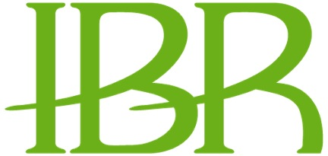 www.ibrweb.com
For more information, please contact: ibr-marketing@ibrweb.com

