PRESS RELEASE

CHROMALUXE BECOMES THE FIRST GOLD SPONSOR OF THE WORLD PHOTOGRAPHIC CUP (WPC)
The 2018 Award Ceremony will be held on the Gold Coast in Australia in May 2018

LOUISVILLE, KY – August 16th, 2017 - ChromaLuxe is pleased to announce that it will become the first Gold Sponsor of the World Photographic Cup (WPC) 2018, increasing its commitment to this major event.

Twenty-nine countries have already registered and more are expected. There are six categories and entries must be submitted by the end of September 2017. The 2018 Award Ceremony will be held on the Gold Coast in Australia, in May 2018.

“This competition brings together some of the world’s greatest and most creative photographers and gives them the opportunity to represent their nation, in this most prestigious event,” said Charles Henniker-Heaton, ChromaLuxe’s WPC Coordinator. “The quality and the originality of the entries, never ceases to amaze me.”

ChromaLuxe first became a sponsor in 2015. Due to the success of the competition and the excellent quality of entries, ChromaLuxe is delighted to be able to extend its support at the Gold level. The company is offering special awards to the individual “Best of Nation” winners and will be closely involved in the new ‘Theme’ challenge that will run during the year on Facebook.

“At the World Photographic Cup, we are all thrilled with the addition of ChromaLuxe as our first GOLD sponsor,” said Don MacGregor, Chairman of the WPC Sponsor committee. “Their management team understands the unique vision of WPC and is 100% behind the goals of uniting the worldwide photographic community in a friendly spirit of competition and enhancing the professional standards. We want to send a global thank you to ChromaLuxe for their support.”

More info: http://www.worldphotographiccup.org
http://www.chromaluxe.eu

Images – See Page 3
For further information and for images for publication, please contact Charles Henniker-Heaton – charleshh@chromaluxe.com

About ChromaLuxe:
ChromaLuxe is the global manufacturer of premium print media, supplying high quality blank substrates for a variety of applications that require superb image quality and durability. All coatings and substrates are made in the USA with manufacturing and fabrication done in Louisville, KY. With additional locations in Belgium and Australia, ChromaLuxe serves its global customer base and provides products to more than 80 countries.

ChromaLuxe HD metal prints bring a new high quality level to dye sublimation printing on aluminum panels. In 2016, ChromaLuxe Gloss White Metal Prints were tested by Wilhelm Imaging Research (WIR) and have achieved three times the print permanence rating compared to archival silver-halide papers. With unprecedented resistance to surface abrasion, high humidity, atmospheric ozone, and contact with water, ChromaLuxe prints, available in sizes up to 1.2m x 2.4 m (4 x 8 feet), can be safely displayed without the need for framing under glass.

ChromaLuxe is an extension of Universal Woods, the world’s leading manufacturer of hard surface sublimatable products and mezzanine decking. It is also a sister brand to Unisub, which provides the highest quality custom sublimatable gift products.
To learn more about ChromaLuxe, follow us on social media.

About WPC:
The WPC was founded in 2013 by The Federation of European Photographers (FEP) and Professional Photographers of America (PPA). Its singular goal is to unite photographers in a spirit of friendship and cooperation. It is also supported by UAPP (United Asian Professional Photography) and AIPP (Australian Institute of Professional Photography). The brotherhood and sisterhood of photography is a bond that transcends language, culture, and geography. That’s the foundation behind the World Photographic Cup, a one of a kind international team competition.

# # #
Note: ChromaLuxe is a registered trademark of Universal Woods, Inc. All other product and brand names are trademarks and/or registered trademarks of their respective companies. ChromaLuxe disclaims any and all rights in these marks.

IMAGES

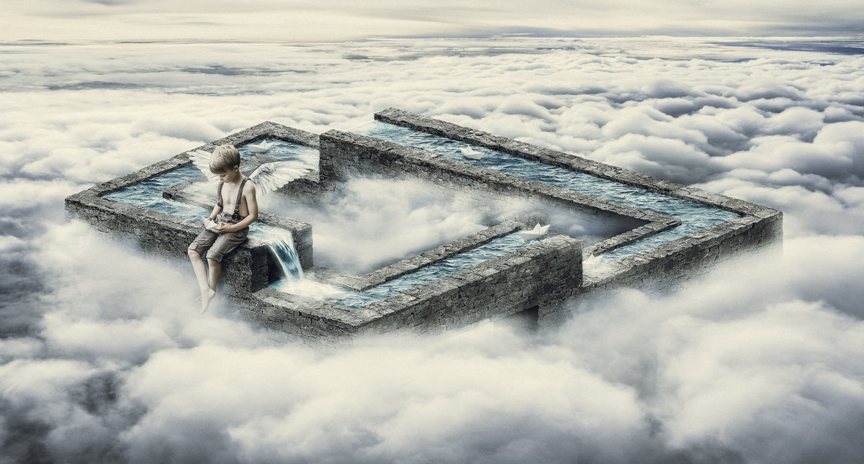
Antti Karppinen, Finland - Gold Medal 2017 Illustration/Digital Art

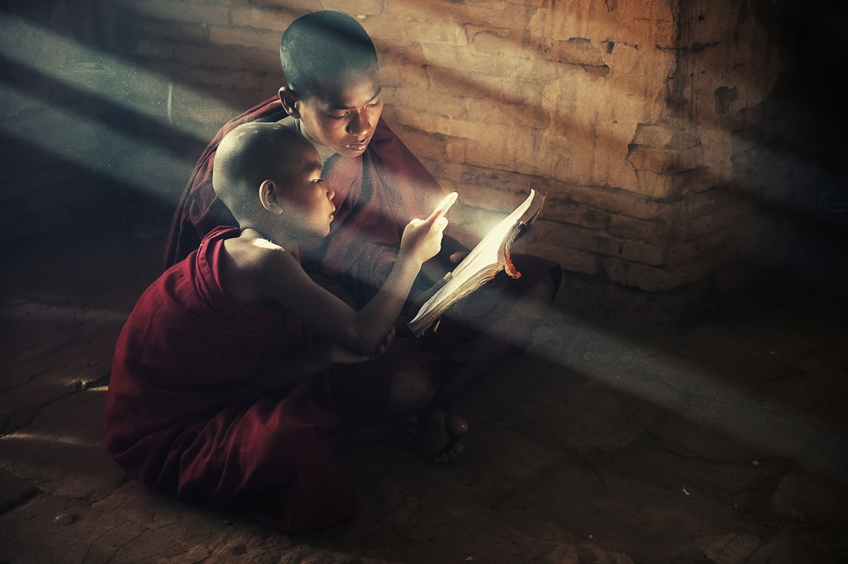
Eelena Malysheva, Russia - Gold Medal 2017 Portrait

For images for publication, please contact Charles Henniker-Heaton – charleshh@chromaluxe.com

