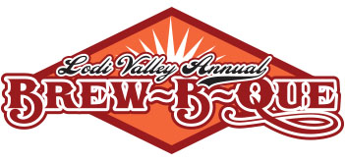

Saturday September 21st, 2019

Downtown-Lodi-Main Street



**Chili Contest Entry Form**

(No Entry Fee)

Prizes Awarded for Crowd Favorite:

* Prizes awarded to 1st & 2nd Place

**Rules and Agenda:**

* Set up begins at 9 a.m.
* Tasting starts at 10am and ends at 3pm. Winner will be announced at 4:30pm
* Cups, spoons, and napkins will be provided to you by the Chamber of Commerce
* Contestant MUST provide their own extension cord 15-20 feet
* **Must bring in a minimum of 2 Gallons of chili or it will not be entered**
* 18-quart Nesco’s work best, crockpots usually run out before judging
* Chamber is not responsible for chili containers after 3:30pm
* You CANNOT serve your Chili, due to liability reasons
* Label your chili if it contains; gluten, dairy or nuts

Please cut along line and return with payment

----------------------------------------------------------------------------------------------------------------------------------------------------------------

Chef Name: ________________________________ Phone Number: ________________________________

Email Address: __________________________________________

I plan to enter in other competitions:

* Salsa (Free to Enter)
* Ribs ($150 to enter)
* Home Brew ($20 for one entry; $10 each for more than one)



Please complete the form and mail it to:

Lodi & Lake Wisconsin Chamber of Commerce

P.O. Box 43

Lodi, WI 53555

*If you have any questions please visit us at [www.lodilakewisconsin.org](http://www.lodilakewisconsin.org) or call the Chamber Office at 608.592.4412 or email [info@lodilakewisconsin.org](mailto:info@lodilakewisconsin.org)