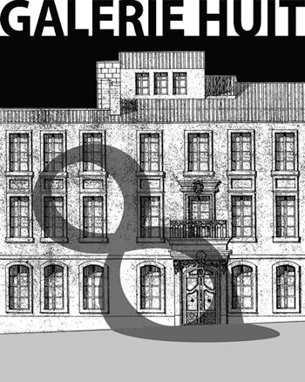
8 rue de la Calade
13200 ARLES
Portable : +33 (0) 6 82 04 39 60
contact@galeriehuit.com
www.galeriehuit.com
Artist in Residency Online Application Form
Can be submitted in French or English
Date :
Name :
Address :
Phone (mobile and/or landline):
Email address:
Website address, if available:
Male/ Female
Date of birth:
Nationality:
Languages:
Current occupation:
What is your specific discipline or field of study:
Please attach an outline to explain the rationale and goals of your project and what you ultimately hope to accomplish during the Galerie Huit residency:

Please indicate your preferred dates and length of stay:
How did you hear about our residency?
How do you plan to fund your stay ?
Does your project have any special needs or requirements, beyond what you are bringing with you?

Required attachments:
Please send the requested attachments along with your online application:
- One reference from an individual familiar with you and your work, including their contact details.
- Resume/Curriculum Vitae
- Work samples or similar, if possible, reflecting the type of project you are pursuing.

Please send completed form and attachments to : contact@galeriehuit.com.

