Shapes and Patterns

Severndroog is full of different shapes and patterns. Find the shapes below and shade or colour them in when you have found them. Say where they are and what they are used for.

Shape | Where did you find it? What it is used for?
Name:
Name:
Name:
Name:
Name
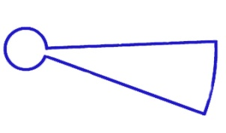
This shape is more difficult to find. Look down as well as up.

