Count and Measure
Are you planning to visit Severndroog Castle? Below you can find a fun list of things to do that will challenge your counting and measuring skills. For some of the activities you may need to ask one of the Castle volunteers or you may need to read some information that you can find inside the Castle. Enjoy!

- How old is the Castle?
- Find out when it re-opened to the public and how long it took the campaign that made this possible.
- Count the sides of the building.
- Count the exterior doors of the Castle.
- Count the interior doors of the Castle.
- Try to guess how tall the Castle is using at least 2 different methods.
- Count the spiral stairs.
- Count the tall windows. Measure some of them. Are they the same?
- Count the small windows that have this shape:
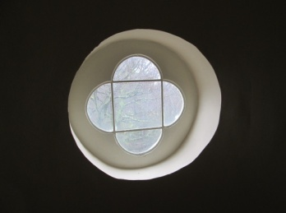

- Count the merlons on top of the Castle.
- How many areas of London can you see from the roof of the Castle?
- Try to guess the distance from the Castle to at least 3 important places/buildings that you can spot from the roof.
- After you’ve found out about the history of the castle, try to draw a time line with the most important events from the life of William James and the Castle, and write the numbers of years between them.

