Maths and Models

Would you like to build your own castle?
Here are some steps that will help you to start your project

- When you visit Severndroog Castle bring a notebook and a pencil for taking notes.
- Draw some of the shapes. You can find out more about these by asking one of the volunteers.
- Pay attention to details like windows, doors, merlons and so on
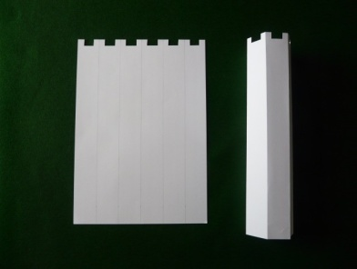
- Try to observe the proportion between the building and its features. If you can measure them - even better!
- Now take 3 sheets of A4 paper or card (one for each turret)
- Divide them in to 6. Draw and cut out the merlons. Use tape to secure the turret sides.
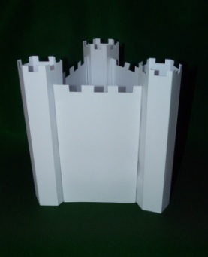
- Now take 3 more sheets of A4 paper for the walls and cut out the merlons.
- Put everything together to create a model of Severndroog Castle.
- The final task is to decorate your model with the features that you observed during your visit

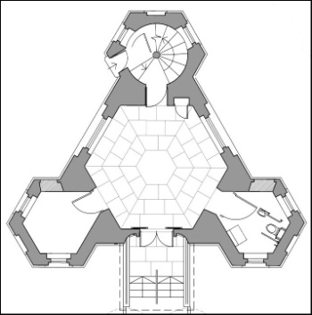

Congratulations! You have your first model of a castle.
Here you can see the shape of a real castle. Is it similar to yours?

If you enjoyed that you could try to make a bigger one with A3 paper and after you’ve practised enough, maybe you can build one from sand or bricks.

