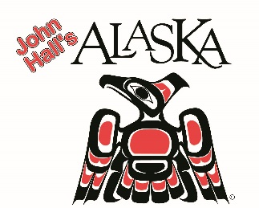

John Hall Sr.
Founder, CEO and President
John Hall’s Alaska

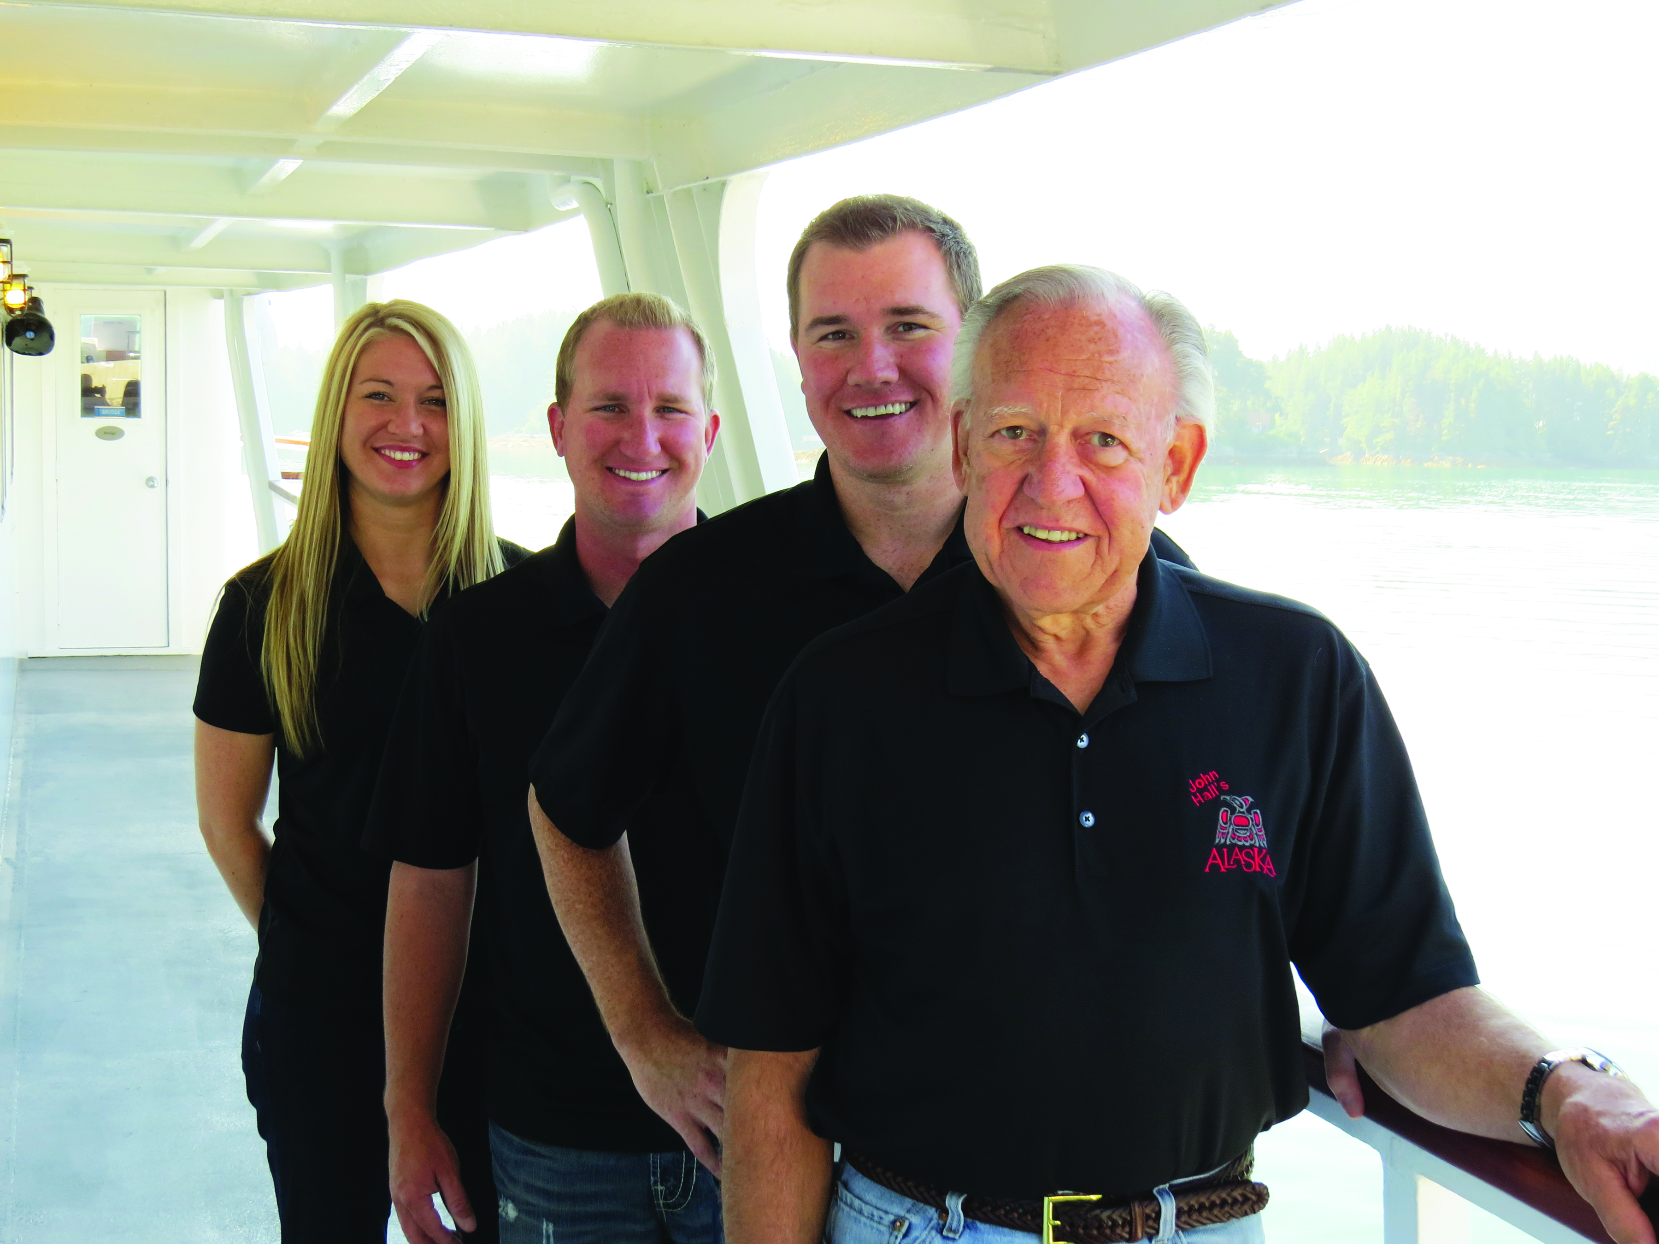

Guided by a love of America’s Last Frontier that dates back 60 years, and an ongoing passion for presenting the best and most comprehensive Alaska travel program in today’s market, John Hall Sr. leads the family-owned and -operated tour company John Hall’s Alaska as Founder, CEO and President.

Hall Sr.’s history with Alaska dates back to 1955 when he was driving with his father on the Alaska Highway in a 1947 Cadillac to deliver 500 cases of fresh eggs to the Piggly Wiggly in Fairbanks. While it wasn’t quite Balto getting the serum through to Nome, the road trip lit a fire in Hall Sr. that has never gone out. From the rushing waterfalls along the roadways to the moose and bear hidden around the bend, Alaska bombarded his senses and fed his appetite for adventure.

Hall Sr.’s family had roots in the hotel business, with three generations on his mother’s side running hotels in Wisconsin and Minnesota. In 1976, he purchased the old family hotel – “The Anderson House” – in Wabasha, Minnesota. It became renowned for offering good home-cooked food from Hall family recipes, as well as for an innovative “Rent a Cat” program offering guests feline companionship for the night, which was covered by national media outlets from Good Morning America to Playboy.

Hall Sr.’s hospitality business took a new turn in 1983 with the purchase of a bus to take guests of The Anderson House to local sporting events, including Minnesota Vikings and Minnesota Twins games. Statewide tours followed, as did winter trips to warm weather destinations. As the motor coach fleet grew, tours were offered to all 50 states and most Canadian provinces, with Alaska among the last destinations available.

In 2001, Hall Sr. sold The Anderson House, but maintained “Anderson House Tours,” which soon became John Hall’s Alaska. The sole focus on Alaska was sparked by Hall Sr.’s realization that there was no other single tour operator putting all of its time and attention into the state.

Hall Sr. raised his three children in The Anderson House. Drawn to hospitality from a young age, they are integral to John Hall’s Alaska today: Eldest son John Hall III is vice president of marketing and Alaska Specialist overseeing the company’s Anchorage operations office. Operations Manager Joseph Hall oversees the motor coach fleet. His only daughter, Elizabeth Hall, started in the company’s tour office when she was in the 9th grade and is now responsible for the entire Alaska operation overseeing all tour programming. Meanwhile, John III’s wife, Lauren Hall, is marketing manager, overseeing the company’s website, social media, catalog, advertising and promotions.

John Hall’s Alaska now offers seven unique itineraries, providing the most extensive and all-inclusive experience into Alaska, the Yukon and the Canadian Rockies beyond.

###

