 | 19 Hartom St., Har Hotzvim Jerusalem 9777518  P.O.B 45003 Jerusalem 9145001 ISRAEL  PHONE: 972-2-6781861  FAX: 972-2-6781852  e-mail: info@novamed.co.il | 
DIASLIDE® URIselect / MacConkey Agar
Catalog No. DS-105

INTENDED USE
Diaslide® Urine Culture Device (UCD) is a semi-quantitative screening culture device for detecting, enumerating and identifying specific bacteria in urine¹. The device is intended for use in physician’s office laboratories (POL) and clinical laboratories as an aid in the diagnosis of urinary tract infection (UTI).

SUMMARY AND EXPLANATION
DIASLIDE® URIselect / MacConkey Agar UCD consists of a transparent, hinged plastic casing containing face-to-face plates of URIselect and MacConkey Agars with a plastic sampler with two bent tips located between.

URIselect Agar
Non-selective enriched medium allows the growth of all UTI pathogens, even those with special nutritional requirements such as group B Streptococci. The medium composition restricts the swarming phenomenon of Proteus spp. assuring better isolation in mixed cultures. The chromogenic and chemical substrates in the agar yield to the direct differentiation of E. coli -Klebsiella - Enterobacter - Serratia (KES), and Proteus - Morganella - Providencia (PMP)-groups and Enterococci. A specificity of URIselect medium allows for the detection of Staphylococcus saprophyticus, which produces light rose-colored colonies. The differentiation between the different bacterial species or genus is achieved by:
- Chromogenic substrates detecting enzymatic activity of the lactose metabolism, which is split with the release of a pink to red dye.
- A chromogenic substrate detecting the activity of Beta-glucosidase, which is split with the release of a blue-green dye. The respective colonies are stained red, (E. coli), metallic-blue, (KES, Citrobacter) or blue-green, (Enterococci, S. agalactiae).
- Tryptophan for the detection of tryptophan deaminase, (TDA) of Proteus-Morganella-Providencia (PMP) group, and for Indole spot tests. The PMP Beta-glucosidase-negative strains produce clear colonies with a diffusible beige-brown pigment and PMP Beta-glucosidase-positive strains produce bluish colonies with a slight brown background.

MacConkey AGAR
A selective medium enables the differentiation between coliforms and non-lactose fermenters with inhibition of Gram-positive micrococci³. Most urinary tract pathogens grow on it, whereas most contaminants are inhibited. Current routine methods for bacteriological examination of urine are the classic Petri dish culture method⁴ and the dipslide technique^{5.} Diaslide® UCD combines the advantages of both techniques, enabling bacterial enumeration and isolation following a simple, user-friendly procedure.

PRINCIPLES OF THE PROCEDURE
The two bent tips of the sampler are dipped into the urine specimen and take up a standard volume of urine. The sampler is then pulled out through the casing, simultaneously inoculating the surfaces of both media with a streaking dilution. As a consequence, the number of bacteria deposited on the media is in direct proportion to the number of bacteria present in the specimen⁶. Following incubation, the number of bacterial colonies cultures is compared with the Colony Density Chart to determine the level of bacteria in the urine sample.

KIT CONTENTS
DIASLIDE® URIselect / MacConkey Agar UCD
Kovac’s reagent) 1 plastic dropper bottle containing 5 ml of reagent) is provided with 500 pcs of DIASLIDE® URIselect / MacConkey Agar UCD.

MATERIAL REQUIRED BUT NOT PROVIDED
Incubator (37 ± 1°C)
Incubation Stand

WARNING AND PRECAUTIONS
1. For In-Vitro Diagnostic Use.
2. Use aseptic techniques and established laboratory procedures in handling and disposing of infectious material.
3. Do not incubate in CO₂

STORAGE
1. Store DIASLIDE® URIselect / MacConkey Agar UCD at 2-8°C.
2. Protect contents from direct light to ensure product stability through the expiration date.
3. Upon opening the bag, store unused Diaslide® UCD units by rolling the open end of the bag and sealing it tightly with tape over the entire length of the opening.

EXPIRATION DATE
1. The expiration date applies to the product in its intact container when stored as directed.
2. Do not use Diaslide® UCD exhibiting any of the following characteristics: discoloration, dehydration, wrinkling or shrinkage of the agar surface and microbial growth prior to inoculation.
3. Avoid use of UCD if an atypical cultural growth occurs during Quality Control procedures.

SPECIMEN COLLECTION
Clean the genital area and collect a midstream urine specimen in a clean container. Inoculate the urine as soon as possible following collection. If storage of the urine specimen is necessary, maintain the specimen at 4°C in a closed sterile container. Storage time should not exceed two hours.

PROCEDURE
1. Remove Diaslide® UCD from its packaging, being careful not to touch the sampler tips.
2. Dip the sampler tips into the thoroughly mixed urine sample, making sure that both tips are immersed up to the point where they meet.
3. Holding Diaslide® UCD vertically with one hand, use the other hand to draw the sampler up through the casing in a straight manner. Discard the sampler.
4. Write patient ID directly on the Diaslide® casing, or apply an in-house ID label as required.
5. Return the Diaslide® casing into its packaging, close firmly and stand upright in the incubation stand.
6. Incubate at 35°C ±2º for 18-24 hours, using aerobic conditions.
7. It is recommended to incubate, in a vertical position using the incubation stand.

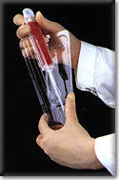 | 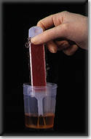 | 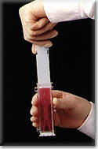 | 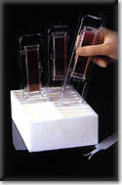
Fig. 1 | Fig. 2 | Fig. 3 | Fig. 4

RESULTS
Following incubation, examine Diaslide® UCD for bacterial growth, which may be evidenced by visible colonies on the agar surface. Since each colony results from growth of a single bacterial cell, and since the sampler takes up a standard volume of urine, the numbers of colonies can indicate the “colony count” of the specimen, the approximate number of bacteria per ml (CFU/ml) of urine. Culture-negative samples can be observed without opening the Diaslide® casing. If microbial growth is present, open the Diaslide® UCD casing and match the “colony density” on the agar surface with the printed illustration it most closely resembles on the Colony Density Chart (See below).

TABLE 1: The relationship between bacterial concentration (CFU/ml) and the approximate colony count of the Colony Density Chart.
ORGANISM | CFU/ml | MacConkey Agar
Escherichia coli | 10³ | 4
Escherichia coli | 10⁴ | 15
Escherichia coli | 10⁵ | 100
Escherichia coli | 10⁶ | -400

INTERPRETATION OF RESULTS
Bacterial count
As a rule, tests yielding ≥10⁵ CFU/ml are regarded as positive (significant level of organism), ≤10⁴ CFU/ml as negative, and between 10⁴ and 10⁵ CFU/ml as borderline, which calls for a repeat assessment⁷. Symptomatic patients having colony counts less than 10⁵ CFU/ml require evaluation based on clinical information. ^{8, 9} Many factors, such as use of antimicrobial therapy, time of urine incubation in the bladder (e.g., first voided urine), and proper specimen collection may influence the colony count obtained. In all cases, the physician must be the final judge of the proper interpretation of Diaslide® UCD test results.

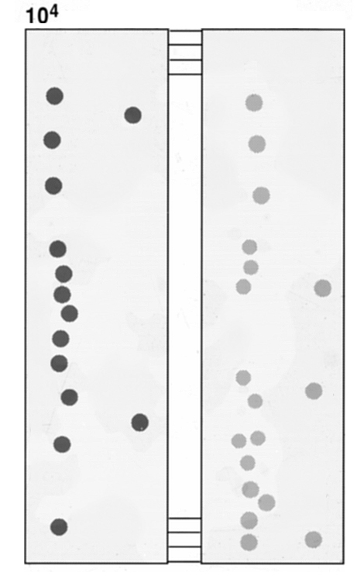
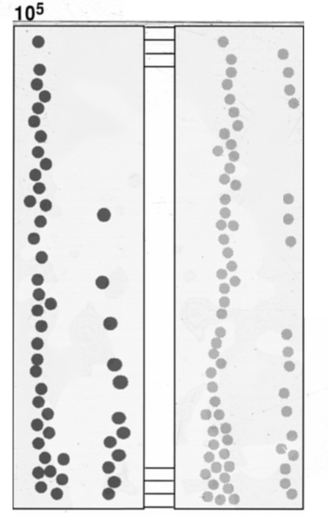
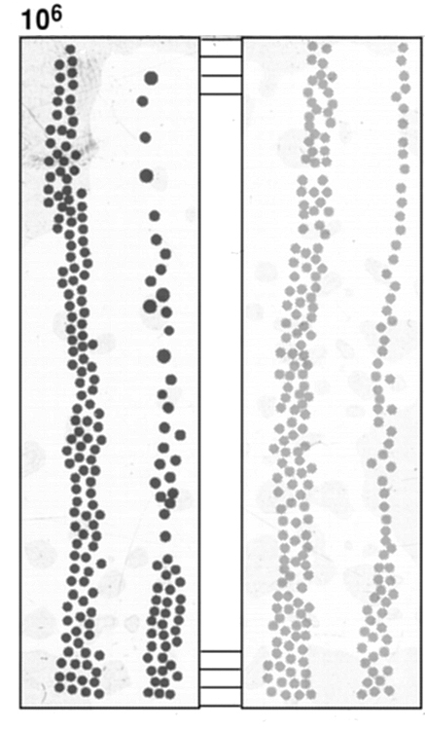
COLONY DENSITY CHART
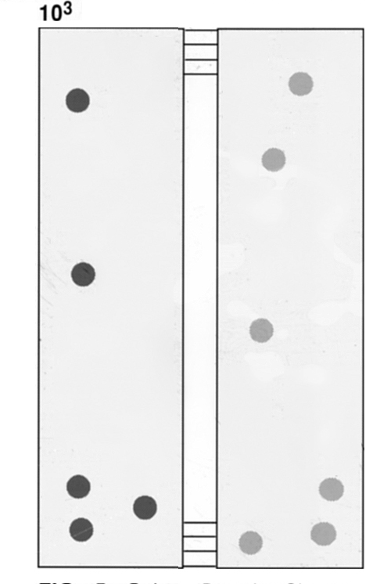
Colony Morphology & Principle of Identification with URISelect 3 Agar

Presumptive identification is based on typical morphology and colony color. Chromogenic URISelect agar enables identification of bacteria by distinct color differences among different types of organisms.
E.coli can be identified based on demonstration of the activity of two enzymes, β-glucuronidase and β-tryptophanase. β-glucuronidase cleaves the first chromogenic substrate contained in the medium, causing the colonies to turn pink. Proteus is characterized by tryptophan deaminase activity; Proteus mirabilis is indole-negative. Enterococci produce a β- glucosidase (esculinase), which cleaves the second chromogenic substrate contained in the medium, causing the colonies to turn turquoise blue.
Revelation of the Various Enzyme Activities
- Spontaneous
For β-glucuronidase and β-glucosidase: change in color of the colonies after incubation at 37°C for
18 to 24 hours.
Positive reaction of β-galactosidase activity – pink color of colonies.
β-glucuronidase activity suggesting presence of E. coli, to be confirmed by testing for indole production:
- indole production indicates on E. coli:
- absence of indole production indicates a need for identification using conventional methods.

Positive reaction of β- glucosidase activity – turquoise blue color of colonies: examine the culture under a microscope:
- COCCI, with small colonies (0.5 to 1.0 mm in diameter) and a bright, frank blue color are Enterococcus species or group B Streptococci. If any of these characteristics is lacking, identify the organism using conventional methods.
- BACILLI, with large colonies (2.0 to 3.0 mm in diameter) and a blue or greenish-blue color are probably KES group organisms (Klebsiella, Enterobacter, Serratia or Citrobacter species) and should be identified using a conventional method.
Negative reaction: No coloration.

- Spontaneous or after addition of a reagent:
Tryptophan deaminase activity (TDA) indicating an organism of the Proteus-Providencia-Morganella group.
Positive reaction of TDA - spontaneously, orange-brown color of the colony, with or without a change on agar color to brown. If the change in color is slight, revelation of the enzyme can be enhanced by depositing a drop of iron perchlorite (FeCl₃) onto a colony: the reagent turns brown-green within a few seconds. Test for indole production: for cultures containing only one kind of organism, deposit one drop of Kovac’s reagent directly onto a brown colony:
- if the color of the reagent does not change within 15 seconds, there is no indole production indicating a Proteus mirabilis;
- if the reagent turns pink within 15 seconds there is indole production indicating an indole+ Proteus, a Providencia, or a Morganella. Precise identification should be performed using a conventional method.
Negative reaction: No coloration on an isolated colony.

Detection of indole production:
For cultures containing only one kind of organism, deposit one drop of Kovac’s reagent on a well-isolated suspect-colony, directly onto the agar:
- if the reagent turns pink within no more than 15 seconds the organism is indole positive;
- if the reagent is still colorless after 15 seconds, the organism is indole negative.

TABLE 2: The relationship between bacterial enzyme activities and the colony morphology on chromogenic URISelect 3 agar

Organism | Colonies morphology |  | Enzyme activities
Organism | Size(Ø mm) | Color | β-glucuronidase | ß-glucosidase | Indole | TDA
E. coli | 2.0 or 3.0 | Pink | + | - | + | -
KES group  organisms | 2.0 or 3.0 | Turquoise blue  or blue purple | - | + | +/- | -
Proteus mirabilis | 2.0 | Orange brown | - | - | - | +
Proteus vulgaris, Morganella, Providencia | 2.0 | Orange brown | - | - | + | +
Enterococcus  faecalis | 0.5 – 1.0 | Bright blue | - | + | - | -
Group B Streptococcus | 0.5 – 1.0 | Bright blue | - | + | - | -
Staphylococcus | 1.0 or 2.0 | White | - | - | - | -

TABLE 3: Interpretation of DIASLIDE® URIselect 3 / MacConkey Agar UCD results

CHROMOGENIC URISelect 3 AGAR SIDE

POSITIVE
NEGATIVE

NO GROWTH
GROWTH

10⁵ or more CFU / ml*

Less than 10⁵ CFU / ml*

Two or less types of microorganisms
More than two types of microorganisms

CHROMOGENIC SIDE | MACCONKEY SIDE | RESULTS
Pink colonies. Confirm with a positive reaction of the colony with the Kovac’s Reagent (the reagent turns pink within 15 sec.). | Pink-red colonies | E.coli
Turquoise blue or blue purple large colonies | Pink-red colonies | Klebsiella, Enterobacter, Serratia  and Citrobacter species
Orange brown color of the colony, with or without a brown color of the agar | Translucent colonies | Proteus, Providencia and Morganella species
Spreading and flat yellowish-green colonies with metallic sheen | Clear colonies | Pseudomonas species
Small or extremely small (0.5 to 1.0 mm in diameter) bright, frank, blue colonies | No Growth | Enterococcus or group B Streptococcus species
White colonies | No Growth | Staphylococcus species
*Each individual laboratory should determine its own cutoff point

Presumptive identification is based on typical morphology and colony color (Table 2).

TABLE 2A. Typical colonial morphology on Diaslide® MacConkey Agar

ORGANISM | MacConkey Agar
Escherichia coli | Round, pink-red, medium size
E. aerogenes | Round, red colored, medium size
Klebsiella pneumoniae | Dark-pink, mucoid, large
Proteus mirabilis | Colorless, translucent, medium size
Pseudomonas aeruginosa | Pink, flat, large
Streptococcus faecalis | No growth
Streptococcus agalactiae | No growth
Staphylococcus aureus | No growth
Streptococcus saprophyticus | No growth
Candida spp. | No growth

TABLE 2B. Typical Cultural Response on URIselect Agar Agar

ORGANISM | URIselect Agar
*Escherichia coli | Pink-red, flat, medium size
E. aerogenes | Metallic blue, mucoid, medium size
Klebsiella pneumoniae | Metallic blue, mucoid, rather big
Proteus mirabilis | Beige to brown on beige background, medium size
Pseudomonas aeruginosa | Creamy, green, non-swarming, rather big
Streptococcus faecalis | Turquoise, small
Streptococcus agalactiae | Translucent, light blue shadowed, small
Staphylococcus aureus | White, compound, medium size
Streptococcus saprophyticus | Pink-light purple convex compound, opaque, small
Candida spp. | Creamy, wet, small
* Confirm for complete identification by Positive Indole spot test with Kovac’s reagent, yielded pink color.

Bibliography

1. Rosenberg, M., S.A. Berger, M. Barki, S. Goldberg, A. Fink and A. Miskin. 1992. Initial Testing of a Novel urine Culture Device. Journal of Clinical Microbiology. p. 2686-2691.
2. The Oxoid Manual, 7th Edition. 1995. Oxoid Unipath, Basingstoke, England. 2-144:2-145.
3. Degre, M. 1970. Quantitative and semiquantitative methods for detection of bacteriuria. Translated from Tidsskrift for Den norske laegeforening 90: 27-30.
4. McAllister, T.A. 1973. The day of the Dipslide. Nephron 11:123-133.
5. Mackey, J.P. and G.H. Sandys. 1965. Laboratory diagnosis of infections of the urinary tract in general practice by means of a dip-inoculum transport medium. British Medical Journal. 2:1286-1288.
6. Kass, E.H. 1957. Bacteriuria and the diagnosis of infections of the urinary tract. Arch. Int. Med. 100:709-714.
7. Clarridge, J.E., M.T. Pezzlo, and K.L. Vosti. 1987. Laboratory diagnosis of urinary tract infections. In Cumitech 2A. American Society for Microbiology, Washington D.C.
8. Isenberg, H.D. and R.F. D’Amaato. 1985. Indigenous and pathogenic microorganisms of humans, p. 30-31. In E.H. Lennette, A. Ballows, W.J. Hausler, Jr., and H.J. Shadomy, Manual of Clinical Microbiology, Washington, D.C.

PACKAGING
Diaslide® URIselect / MacConkey Urine Culture Device 10 tests
10 x 10 tests DS-105

IFU-Diaslide-DS-105-v.03-08.05.19

